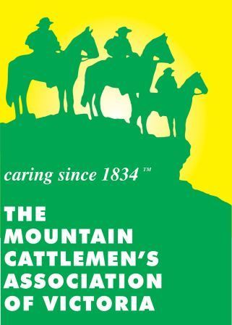
MCAV PARTICIPANT WAIVER 2023
By signing this form, you agree to abide by the Rules & Conditions of the MCAV and any Rules of the event.
Horse Sports are a Dangerous Activity
I, the undersigned, in consideration for being permitted to participate in any way in horse sport activities and in particular this event, acknowledge and accept that:
Horse sports are a dangerous recreational activity and horses can act in a sudden and unpredictable way, especially if frightened or hurt.
There is a significant risk that serious injury or death may result from horse sport activities and in particular this event and freely assume all such risks, even if arising from the negligence of the MCAV and/or the event organiser / official.
I voluntarily participate at my own risk and assume sole responsibility for any injury, death or property damage I may suffer that arises from my participation in horse sport activities.
I understand and acknowledge the dangers associated with the consumption of alcohol or any mind-altering drugs before and during the activity and I take full responsibility for any injury, loss or damage associated with their consumption.
I agree to follow the directions of any event organiser or official and that any misconduct or refusal by me to follow any direction of any organiser or official can result in the cancellation of my participation in the event and my immediate removal from my horse no matter where that may occur. I further agree to abide by the Rules and Conditions of this event and the official Rule Book of the Pony Club Association of Victoria. I understand that any such non-compliance may result in injury, death and/or permanent disability and I agree to indemnify MCAV against all claims made by any person as a result of my failure to comply.
I agree to wear a helmet at all times whilst riding and agree that I am solely responsible for ensuring that I wear a suitable helmet at all times while riding and take sole responsibility for my actions.
I, for myself and on behalf of my heirs, assigns, personal representatives and next of kin, hereby release and hold harmless and agree not to sue the directors of the Mountain Cattlemen’s Association of Victoria and/or the event organiser, their officers, officials, volunteers, coaches, agents and/or employees, other participants, sponsoring agencies, sponsors, and if applicable, owners and lessors of premises used to conduct the activities (all of whom are referred to as “Releasees”) with respect to any and all injury, disability, death, or loss or damage to person or property, whether caused by the negligence of the Releasees or otherwise.
Effect of this Document -I have had sufficient opportunity to read this release of liability and assumption of risk agreement, fully understand its terms, understand that I have given up substantial rights by signing it, and sign it freely and voluntarily without inducement of any kind. I understand that my signature to this document constitutes a complete and unconditional release of all liability of the Releasees, to the greatest extent allowed by law in the event of me and/or the children under my care, suffering injury or death.
In consideration of your accepting my participation, I hereby undertake to indemnify the organising body against all claims, losses, suits and damages made against or suffered by the organising body by reason of any negligent act or omission on the part of any rider, driver, trainer or attendant whilst he/she is attending, riding, driving or otherwise handling any horse so entered or any other horse owned or entered by me, and I agree that any act or omission on the part of such rider, driver, handler or attendant found in any action against you to be negligent shall be deemed to have been negligent for the purpose of any claim under this indemnity.
Further, I agree to abide by the Rules & Conditions and current Rule Book as laid down by the Mountain Cattlemen’s Association of Victoria and/or contained in any official event schedule and I also agree to abide by all of the Event Venue rules regarding use of their centre and its facilities.
Full Name:
D.O.B:
Address:
Postcode:
Signed:
Contact Phone:
For Participants of Minority Age (Under Age 18)
This is to certify that I, as a parent/guardian with legal responsibility for this participant, acknowledge, understand and accept all of the above and consent and agree to his/her release as provided above of all the Releasees, and, for myself, my heirs, assigns, and next of kin, I release and agree to indemnify and hold harmless the Releasees from any and all liabilities arising from my minor child’s involvement or participation in horse sport activities and in particular, this event, even if arising from the negligence of the Releasees.
Full name of Rider:
D.O.B:
Address:
Postcode:
Full Name of Guardian:
Contact Phone
Signature of Guardian

