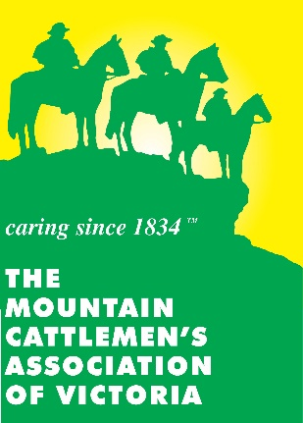

2020 Mountain Cattlemen’s Association of Victoria Annual Get Together
Biosecurity Horse Health Declaration

Event Name: 2020 MCAV Merrijig Get Together
Arrival date:
Departure date:
Competitors Name:
Owner or person in charge of horse/s:
Home Address:

Phone:
Email:
Vehicle Registration Number:
Property address of rigin of horse if different from above:

PIC number (if valid):

Details of all horse/s being bought on to MCAV Merrijig grounds:

Please list horse name, brief description, sex, microchip/branding, PIC of property they are returning to and if the horse in Hendra vaccinated:

Horse 1:

Horse 2:

Horse 3:

Horse 4:

Horse 5:

Horse 6:

Declaration by owner or person in charge of horse/s attending:
I declare that the horse/s named above and/or below has / have been in good health, eating normally and not shown signs of illness during the last three days leading up to this event. I give my authorisation for the Event Organising Committee/Biosecurity Manager to call for veterinary inspection of the horse/s named above and/or below and in my care should they be showing signs of illness at any time during the course of the event. I agree to pay any veterinary fees incurred for the abovementioned horses as a result of this veterinary examination.

I AGREE TO ENSURE THAT:
- All horses, vehicles and equipment accompanying horse/s will be clean and free of solid material (that could contain disease agents) prior to departing property of origin.
I FURTHER DECLARE THAT:
2. The information contained in this Biosecurity Declaration is true and correct to the best of my knowledge.
3. I agree to abide by all conditions that may be imposed at any time by the Event Organising Committee/Biosecurity Manager.
4. I acknowledge that in failure to comply, I may be directed to leave the event and my nominations will be forfeited.
5. I acknowledge that decontamination and disinfection procedures may be required of me if instructed by the Event Organising Committee/Biosecurity Manager.
6. I acknowledge that there is a possibility that horses might become infected with disease agents as a result of any movements and if necessary horses and premises will be quarantined in accordance with any legislation covering such occurrences including policies and procedures in effect at that time. I agree and acknowledge that the Biosecurity Manager/Event Organising Committee, Mountain Cattlemen’s Association of Victoria and the members are not in any way liable for any cost, expense, loss, damage, claim, action, proceeding or other liability incurred by or made against me as a result of any movement of horses to the event/farm.

Name:

Signature:

Date:

