Kids fire craft activity
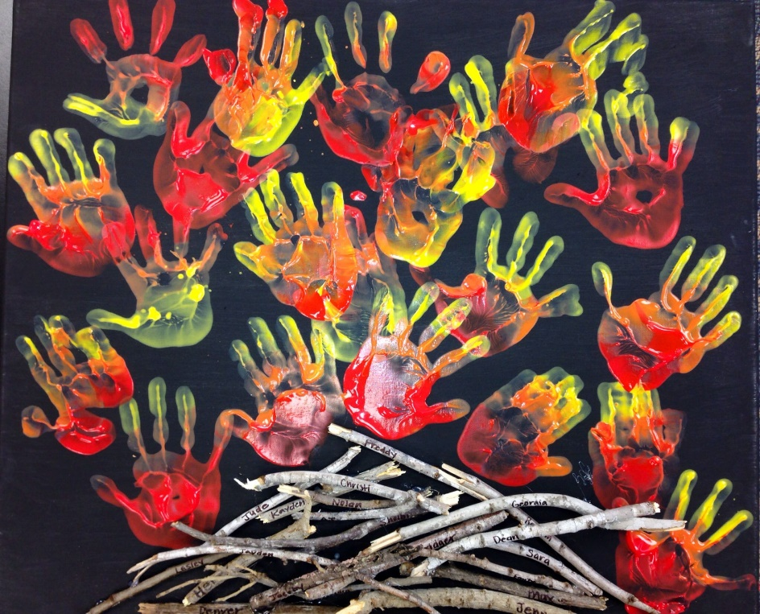

You will need:
- A collection of sticks
- Black texta / fine paint brush
- Orange / red / yellow poster paint
- PVA Glue
- Posterboard / paper

Instructions:
- As a class or individually, have students collect sticks from their local environment.
- On returning to the creative space, have all students write a word that they associate with fire (or their name) on a stick. This can be done with either a fine paint brush, finger painting or black texta.
- Have each student apply glue to their stick and place it onto a piece of posterboard.
- Have students paint their hands with posterpaint, red across the heel, orange across the palm and yellow for the fingertips.
- Each students places their hands on top of the sticks, creating a ‘flame’ affect.

